
Name: Talha Arshad
Roll Number: 302-221110
Instructor: Zulfiqar Ahmed
Date: 14-5-2025

Web Engineering
Local Event Finder

Assignment 1

Introduction
This project is a web-based application designed to help users discover local events such as workshops, festivals, or meetups. It offers an intuitive and responsive interface that allows users to filter events dynamically based on different criteria like category, location, and date. Additionally, users can mark events as favorites, which are stored using the browser's localStorage, so their preferences are retained even after refreshing the page.

Features Implemented
- Responsive Layout:
The user interface is designed using CSS Flexbox and Grid to ensure a fluid and adaptive experience across various screen sizes—from desktops to mobile devices.
- Event Cards Display:
All events are displayed as visually distinct cards. Each card shows key event details such as:
  - Title
  - Category (e.g., Workshop, Festival, Technology)
  - Date and time
  - Location
A favorite (☆) icon is also included to allow user interaction.
- Dynamic Filtering System:
Users can filter events in real time without page reload. The following filters are available:
  - Category – Selectable from a dropdown (e.g., Workshop, Art, Music)
  - Date – Selected via a date picker input
  - Location – Free-text input to match city or venue names
- Favorite Events with localStorage
  - Users can click on a star icon (☆) to mark events as favorites.
  - Favorite selections are stored in the browser's localStorage.
  - On page reload, the application reads from localStorage to restore the user's favorites automatically.
- Sample Data Integration:
  - The application includes 10+ manually curated sample events coded directly into the JavaScript file.
  - These events span multiple categories and locations to support meaningful filter testing.
- Filter Persistence :
  - When users apply filters, their selections are also saved to localStorage.
  - Upon returning to the application, the same filters can be re-applied for continuity.

Screenshots
- Homepage with All Events Displayed
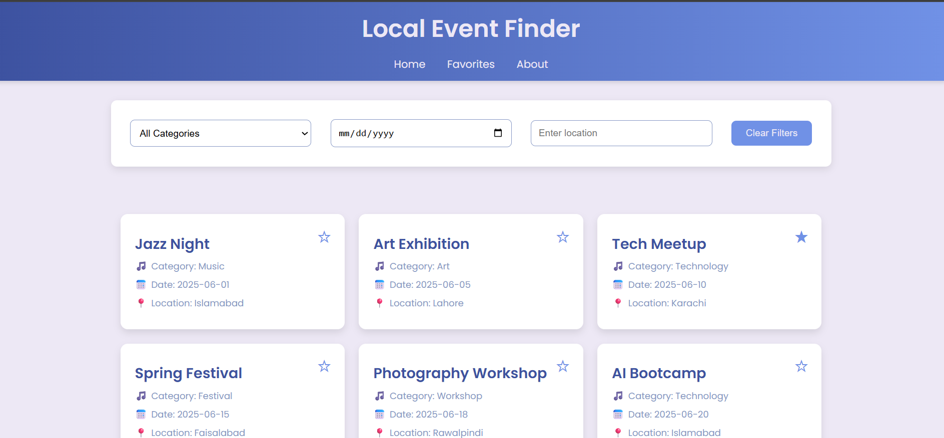
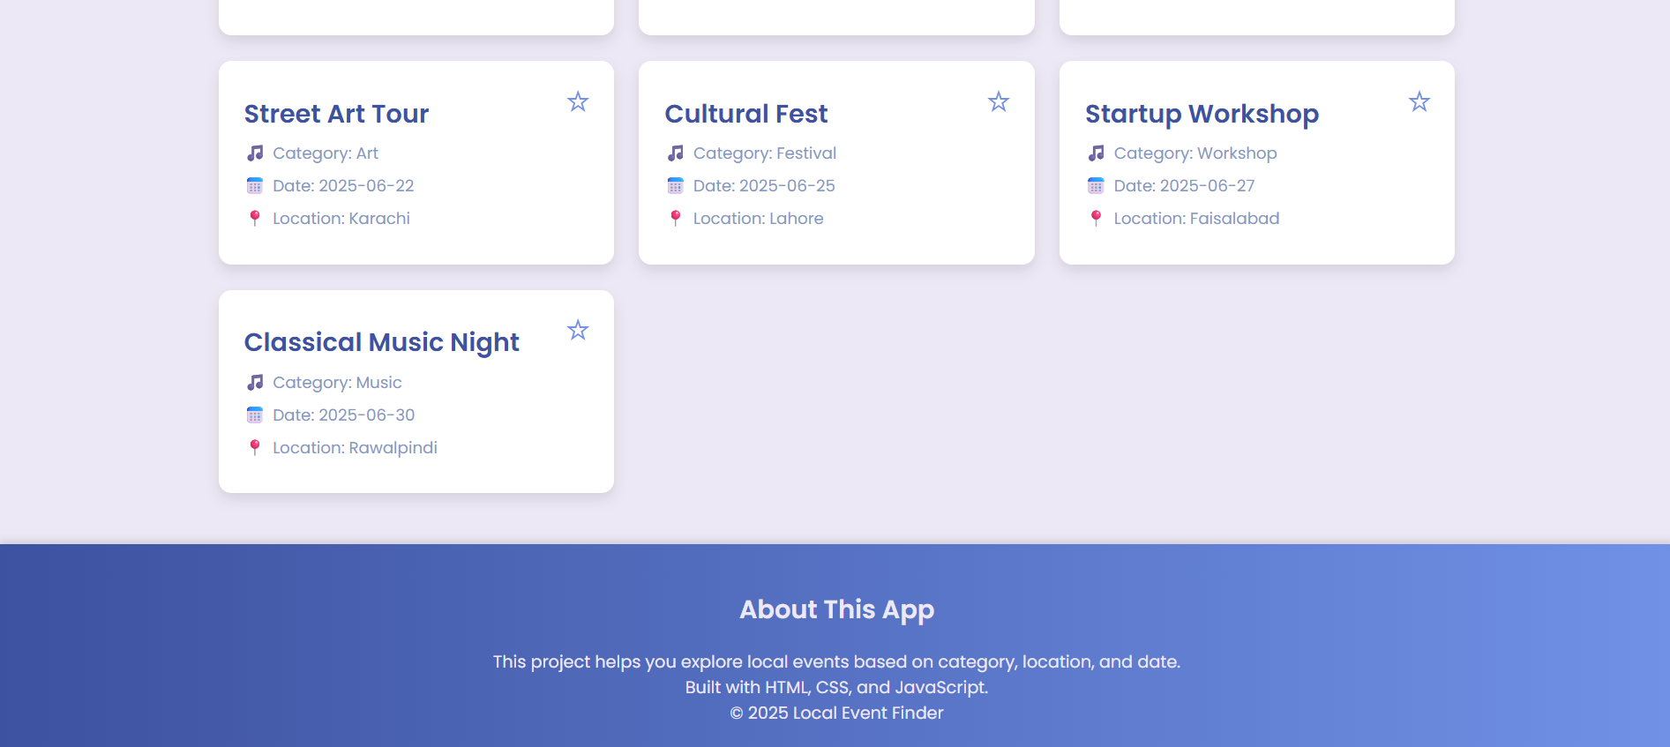

2. Using Filters (e.g., Location or Category)
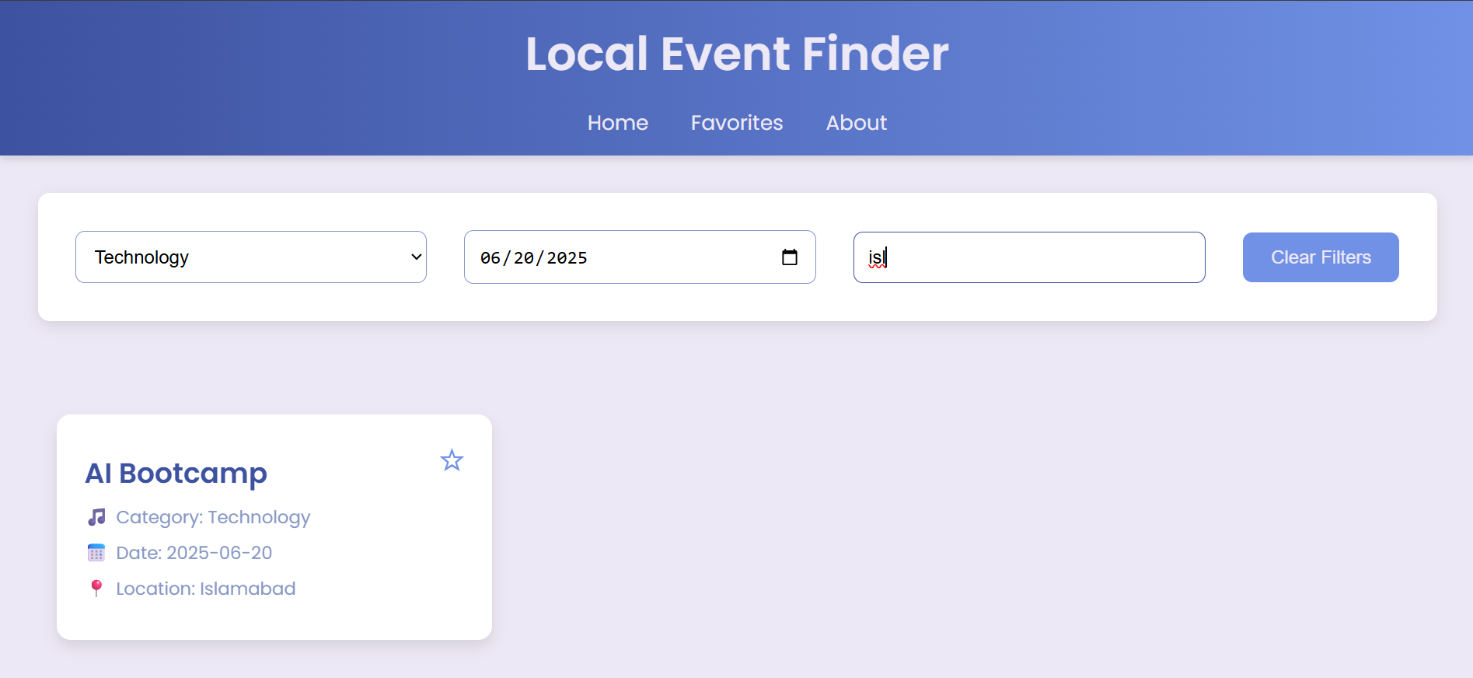
3. Favorite Events
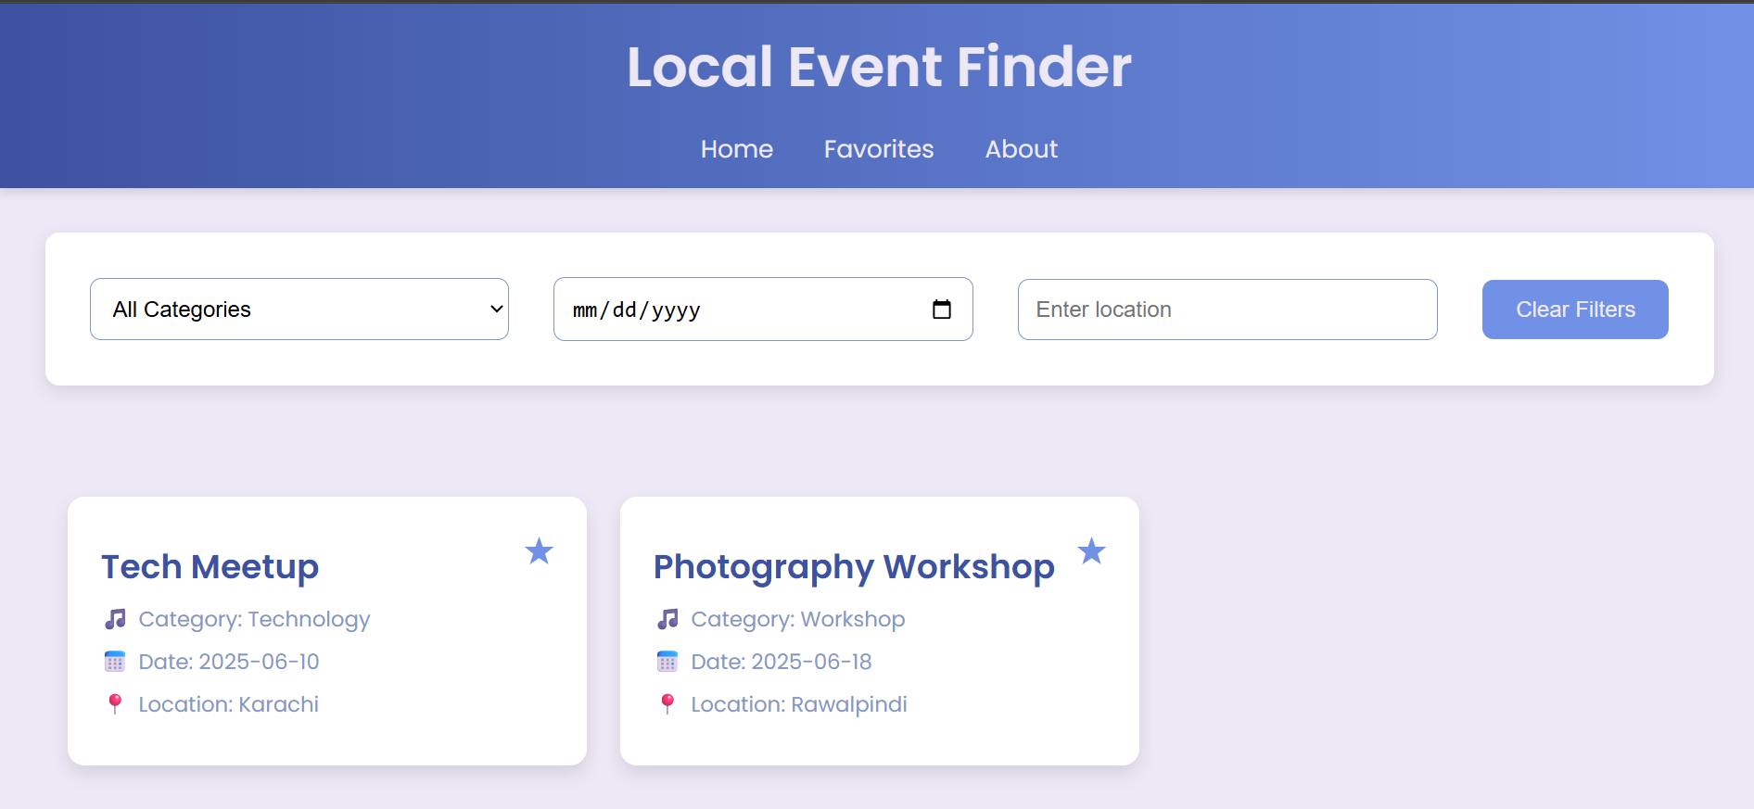

Technologies Used
- HTML5 – For structuring the page
- CSS3 – For styling and layout (Flexbox & Grid)
- JavaScript (ES6+) – For dynamic filtering and interaction
- LocalStorage API – To save favorite events and filter preferences

How to Run the Project
- Download and extract the .zip folder.
- Open the index.html file in any web browser.
- Browse the listed events.
- Use the filter section to search for specific events by category, location, or date.
- Click the star icon (☆) to favorite events.
- Refresh the page – your favorite events will remain saved via localStorage.

Conclusion
This project demonstrates the integration of front-end web technologies to create an interactive and user-friendly event browsing experience. It combines clean design with real-time filtering and persistent storage to deliver a functional event finder.

